Manifest Searching

CNS – Ports

This section covers how to manifest search vessels arriving at London Gateway and Tilbury port on the CNS system.

Our current procedure is to browse the manifests on Monday for all vessels arriving at London Gateway and Tilbury over the next 7 days (Tuesday – Monday). You should avoid placing a hold on containers which are due to arrive on the present day as the agent will have arranged ongoing transport.

- Visit www.cnsonline.co.uk, enter your login details and click the CNS COMPASS icon
- On the menu bar, click Maritime Import and Voyage Search.

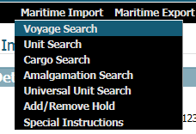

- On the left-hand menu, enter the following:
  - Site/Wharf – enter ‘LGP1’ for London Gateway or ‘JWQ1’ for Tilbury
  - Expected Arrival Date – enter the date range for Tuesday – Monday

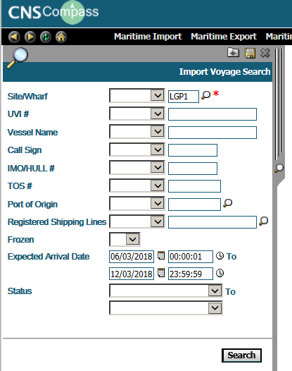

- Click Search.
- You are now shown a table with all the vessels arriving within your specified date range. The main columns of interest are Vessel Name, Port of Origin and Expected Arrival Date.

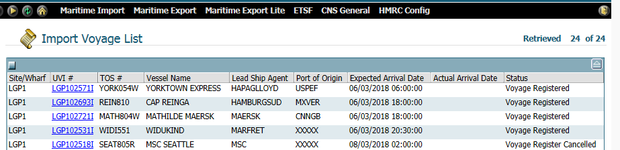

- Click on the UVI (underlined in blue) in the first row to open details of this vessel. You can also see the Vessel Name, Port of Origin and Expected Arrival Date at the top of this screen.

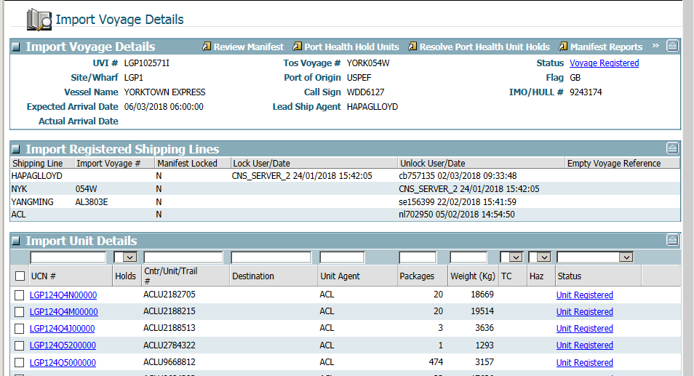

- Click Review Manifest.

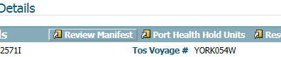

- Under the heading ‘Import Available Cargos’, you are shown a breakdown of the containers on this vessel and the corresponding Cargo Goods Description. At the bottom of this table you will see the text ‘Show’ – select ‘100’ from the drop-down menu so you can see as many containers as possible on one page.

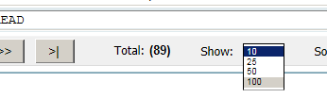

- If you see any goods of interest under the ‘Cargo Goods Description’ make a note of the container number, country of origin and expected arrival date. Keep scrolling through all goods on this vessel.
- Close the window and press the screen back button to return to the list of vessels due to arrive, click on the next UVI and repeat the process.
- Once all ships have been checked you will need to select which consignments to hold from those you noted may have goods of interest.
- Go to Maritime Import and Add/Remove Hold

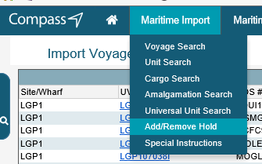

- Type the port reference code into the ‘Site/Wharf’ box in the top centre of the screen

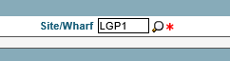

- Type the container numbers you wish to hold, select the hold type from the drop down menu (Trading Standards Hold K1) and type the following text into the reason box so the shipping agents know who to contact:

“Thurrock Trading Standards / Please submit Declaration, Bill of Lading, Commercial Invoice and Packing List by email to tsports@thurrock.gov.uk”

- Once all of the boxes are filled in click Apply Holds, multiple containers can be held at once.

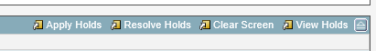

- Wait for the screen to refresh and check that a message comes up in the ‘Comments’ section that the hold has been applied for each container.
- Record on the holds spreadsheet what holds you have placed.
- Wait for the shipping agents to email the requested paperwork.

CNS – ETSF’s

This section covers how to manifest search consignments arriving at one of the ETSF’s in Thurrock on the CNS system.

Our current procedure is to browse the manifests on Monday for all consignments arriving over the next 7 days (Tuesday – Monday). You should avoid placing a hold on containers which are due to arrive on the present day as the agent will have arranged ongoing transport.

- Visit www.cnsonline.co.uk, enter your login details and click the CNS COMPASS icon
- Ensure Internet Explorer is in Compatibility View (Tools > Compatibility View > Add)
- On the menu bar, click ETSF and Unit Search.

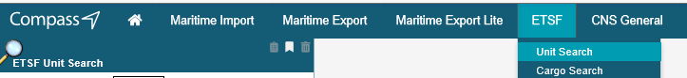

- On the left-hand menu, enter the following:
  - ETSF Site Code – e.g. ‘FPY1’ for Youngs
  - Expected Arrival Date – enter the date range for Tuesday – Monday

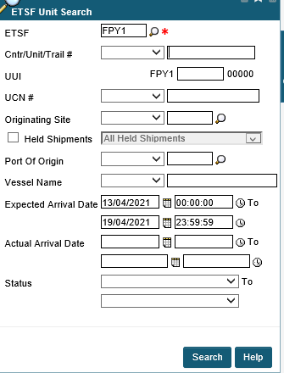

- Click Search.
- You are now shown a table with all the consignments arriving within your specified date range, the container this consignment has travelled in, the number of cartons and the vessel name.

- Click on the UCN (underlined in blue) in the first row to open details of this consignment. You can also see the Vessel Name, Port of Origin and Expected Arrival Date at the top of this screen.

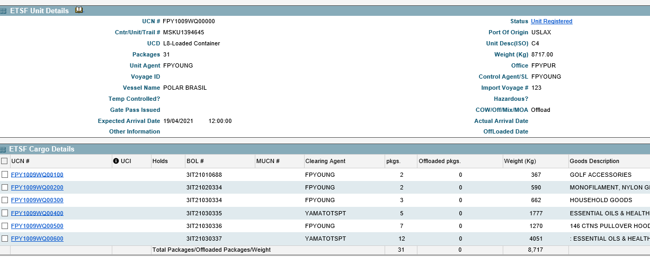

- Look at the ‘Goods Descriptions’ and if any are of interest select that UCN in the left column where the UCN’s are highlighted blue and underlined.
- A new window opens showing only that UCN, click Holds in the top right corner.

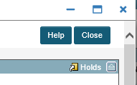

- Click Add Holds.

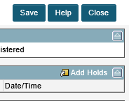

- Select the Hold Type from the drop down menu, and in the Reason box type the following:

“Thurrock Trading Standards / Please submit Declaration, Bill of Lading, Commercial Invoice and Packing List by email to tsports@thurrock.gov.uk”

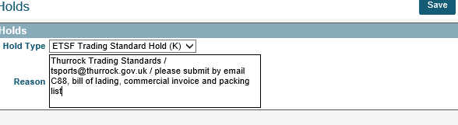

- Click Save.
- Check a padlock symbol appears next to the UCN to show a hold is in place, and if no other UCNs of interest in from that container press the back-up button.
- Select the next UCN in the list and repeat the process.
- Do this for each ETSF in the area.
- Record on the holds spreadsheet as you place each hold.
- Wait for the shipping agents to email the requested paperwork.

Destin8 – Tilbury port

This section covers how to manifest search vessels arriving at Tilbury port on the Destin8 system.

Our current procedure is to browse the manifests on Monday for all vessels arriving at Tilbury over the next 7 days (Tuesday – Monday). You should avoid placing a hold on containers which are due to arrive on the present day as the agent will have arranged ongoing transport.

- Visit www.destin8.co.uk, enter your login details and the appropriate letters/numbers from the memorable text.
- On the left menu, click Vessel and Enquiry

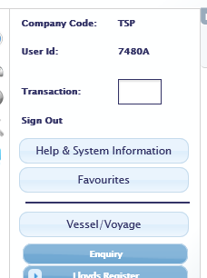

- Select ‘GBTIL – Tilbury’ from the Working Port drop down menu
- Change the Arrival Date to tomorrow and the end date to 1 week from tomorrow

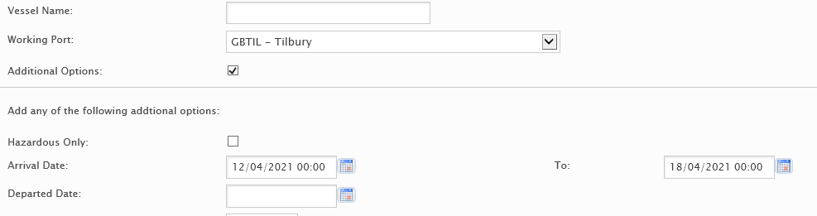

- Click Go at the bottom of the page
- Click the ETA/Arrival date to change the order of ships into the earliest arrival first

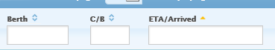

- The vessel name, berth, shipping company and estimated arrival date are all displayed. For Tilbury port we want ships showing ‘LCT’ under Berth, and for Tilbury2 we want ships showing ‘T2R’. Ships showing ‘RRR’ are RO-RO (drive-away trailer ferries rather than container ships) so will already have drivers waiting to remove them from site. This needs to be considered as it will cause more inconvenience to all if holding these.
- Pick the first ship and click on the UVI number
- A new window will open showing more details about the ship, including the port of origin and destination ports

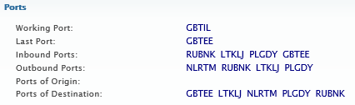

- Under the Voyage section select the box with an arrow in it next to the UVI number, then select Import Enquiry

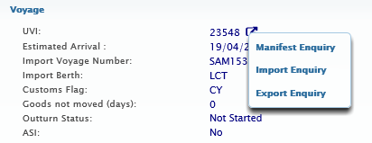

- If no manifests have been input yet a message will pop up in the top right corner saying there are no details

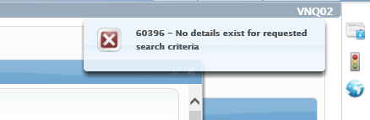

- If manifests have been input then the window will change to show the details, including the UCN, container number (unit ID), bill of lading, port of origin and goods descriptions.
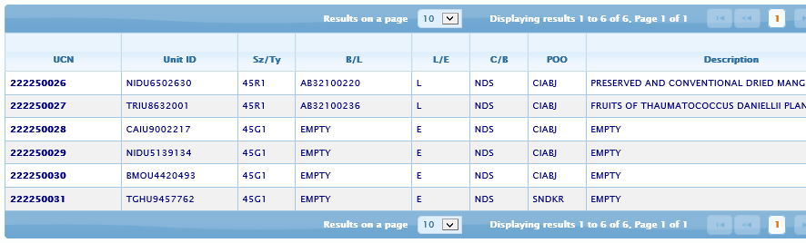

- If you wish to place holds as you find goods of interest then please continue to follow this procedure. If you wish to check all ships due to arrive and then select which consignments to hold please move to the next page.
- Click on the UCN number of any goods of interest, a new window with further consignment details pops up.

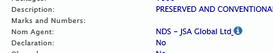

- Click the square box with an arrow in it next to the UCN.
- Select Import Local Hold.
- In the box that opens select Hold and Enter information in the document request field, add your initials and click Go.

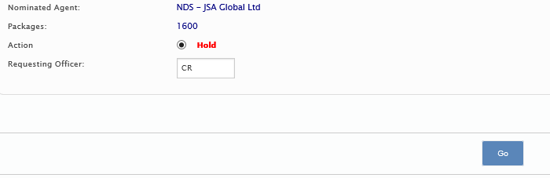

- Check the consignment information has updated to show the hold now in place.
- Record on the holds spreadsheet as you place each hold.
- Wait for import paperwork to be emailed in

- If you wish to check each ship due to arrive please continue procedure from here.
- Look through each page for any goods of potential interest and make a note of their UCNs and/or container numbers.
- Before moving to the next page of consignments click on the UCN number of any goods of interest, a new window with further consignment details pops up.

- Once all ships have been checked select which consignments you wish to hold.
- In the left menu click Imports then select Hold/Examination and Local Hold.
- In the main screen type either the Unit ID (Container number) or UCN, make sure the Hold option is selected, then type your initials in next to Requesting Officer.

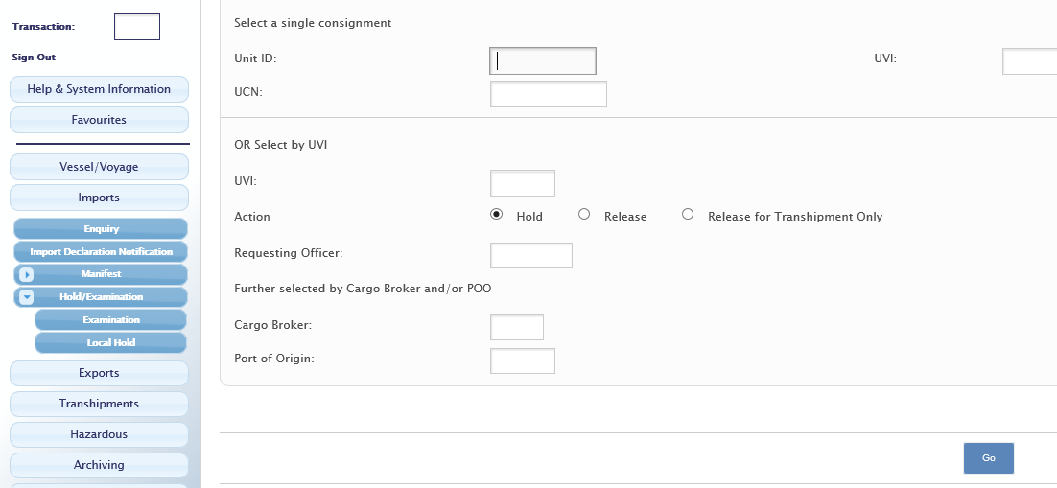

- Click Go.
- Repeat the requested details in the next window.
- Record on the holds spreadsheet as you place each hold
- Wait for import paperwork to be emailed in.

