Email to Home Authority detailing the results.

Result of sample(s) taken at the border to Home Authority
Dear Duty Team

Please find attached the results of a sample(s) taken from a consignment imported via the Port of Felixstowe.

This relates to an importer based in your area, or the delivery address provided is within your local authority. The consignment has been released to the delivery address.

This authority conducts product safety assessments at the border as part of our role as a Market Surveillance Authority. We are notifying you so that you may liaise with the business at the delivery address/fulfilment house to prevent unsafe or non-compliant goods from being distributed to consumers.

To ensure that all relevant information is available to colleagues and is included in any intelligence analysis to influence future product safety work, we request that your authority records the outcome of any intervention on IDB as well as the national Product Safety Database: https://www.gov.uk/guidance/product-safety-support-for-local-authorities. Follow this link to update your case: (Add Link)

Suffolk Imports Team would like to receive feedback regarding the actions you have taken following this referral. It is appreciated that timescales will vary, depending on the nature of the referral. We will therefore contact you in approximately one month, for feedback on this referral.

If you believe this referral is not for your authority (e.g. trader out of area), please notify us as soon as possible.

Kind regards,

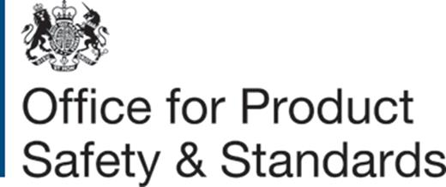 | Suffolk Imports Team  Phone: 01473 264563  Team Email: imports@suffolk.gov.uk  Suffolk County Council | Trading Standards  Landmark House | 4 Egerton Road | Ipswich Suffolk | IP1 5PF

Email to Agent requesting further information.

Request for urgent information, consignment held at the border - Our Ref WK/
UCN:
Container No:
Entry No:

This consignment has been selected for exam. The below information is required within the next 3 days, until this information is provided the goods will remain on hold at the border:
- A detailed packing list with individual carton numbers.
- A copy of the Declaration of Conformity along with supporting technical documentation to demonstrate that the … have been assessed against … (as necessary)
- Compliance documentation to show the … has been assessed against relevant safety legislation.(delete as appropriate)
- Photos or Links to the selling page of the selected products.
- Confirmation of the delivery address.
- A contact email address for the importer.

Please ensure you use the reference number in the subject header in all correspondence.
Kind regards,

Suffolk Imports Team
Phone: 01473 264563
Team Email: imports@suffolk.gov.uk
Suffolk County Council | Trading Standards
Landmark House | 4 Egerton Road | Ipswich Suffolk | IP1 5PF

