Manifest Searching – Destin8

This section covers how to manifest search vessels arriving at Tilbury port on the Destin8 system.

Our current procedure is to browse the manifests on Monday for all vessels arriving at Tilbury over the next 7 days (Tuesday – Monday). You should avoid placing a hold on containers which are due to arrive on the present day as the agent will have arranged ongoing transport.

- Visit www.destin8.co.uk, enter your login details and the appropriate letters/numbers from the memorable text.
- On the left menu, click Vessel and Enquiry

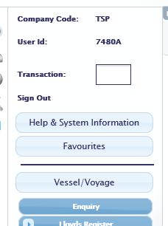

- Select ‘GBTIL – Tilbury’ from the Working Port drop down menu
- Change the Arrival Date to tomorrow and the end date to 1 week from tomorrow

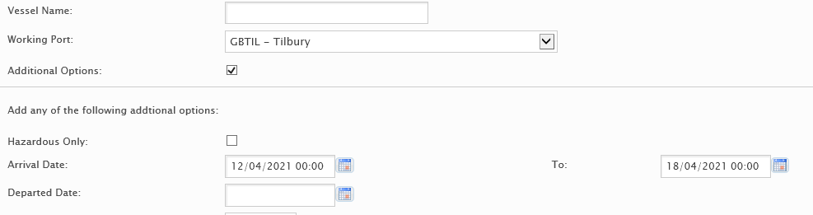

- Click Go at the bottom of the page
- Click the ETA/Arrival date to change the order of ships into the earliest arrival first

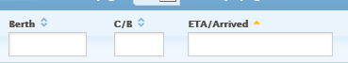

- The vessel name, berth, shipping company and estimated arrival date are all displayed. For Tilbury port we want ships showing ‘LCT’ under Berth, and for Tilbury2 we want ships showing ‘T2R’. Ships showing ‘RRR’ are RO-RO (drive-away trailer ferries rather than container ships) so will already have drivers waiting to remove them from site. This needs to be considered as it will cause more inconvenience to all if holding these.
- Pick the first ship and click on the UVI number
- A new window will open showing more details about the ship, including the port of origin and destination ports

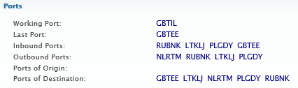

- Under the Voyage section select the box with an arrow in it next to the UVI number, then select Import Enquiry

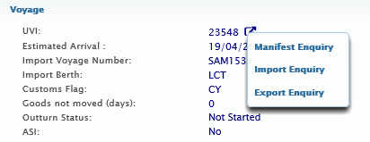

- If no manifests have been input yet a message will pop up in the top right corner saying there are no details

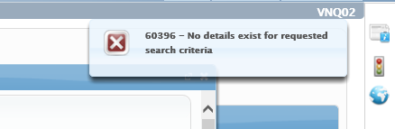

- If manifests have been input then the window will change to show the details, including the UCN, container number (unit ID), bill of lading, port of origin and goods descriptions.

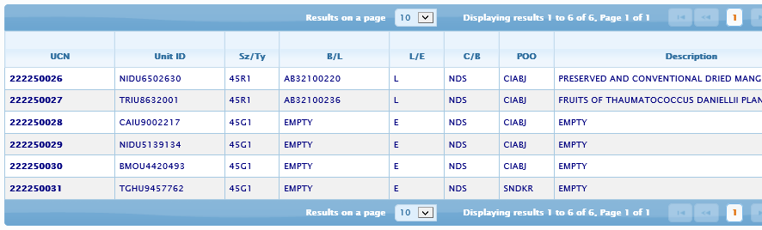

- If you wish to place holds as you find goods of interest then please continue to follow this procedure. If you wish to check all ships due to arrive and then select which consignments to hold please skip to the next page.
- Click on the UCN number of any goods of interest, a new window with further consignment details pops up.
- Make a note of the Nom agent so you can contact them to request import paperwork. Move the mouse curser over their name and a little ‘i’ symbol appears, click this button and contact details of the shipping agent will open.

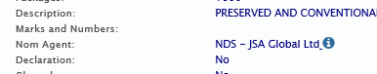

- Click the square box with an arrow in it next to the UCN.
- Select Import Local Hold.
- In the box that opens select Hold and type your initials, and click Go.

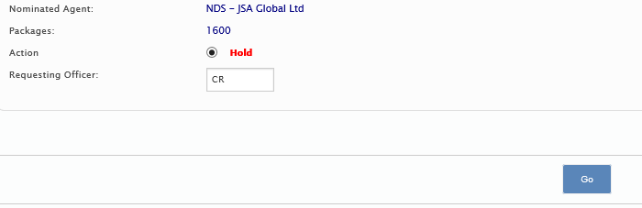

- Check the consignment information has updated to show the hold now in place.
- Record on the holds spreadsheet as you place each hold.
- Email each shipping agent with a list of their consignments you have held and ask them for the following:

“Please submit by email C88, bill of lading, commercial invoice and packing list to tsports@thurrock.gov.uk”

- Wait for import paperwork to be emailed in

- If you wish to check each ship due to arrive please continue procedure from here.
- Look through each page for any goods of potential interest and make a note of their UCNs and/or container numbers.
- Before moving to the next page of consignments click on the UCN number of any goods of interest, a new window with further consignment details pops up.
- Make a note of the Nom agent so you can contact them to request import paperwork. Move the mouse curser over their name and a little ‘i’ symbol appears, click this button and contact details of the shipping agent will open.

- Once all ships have been checked select which consignments you wish to hold.
- In the left menu click Imports then select Hold/Examination and Local Hold.
- In the main screen type either the Unit ID (Container number) or UCN, make sure the Hold option is selected, then type your initials in next to Requesting Officer.

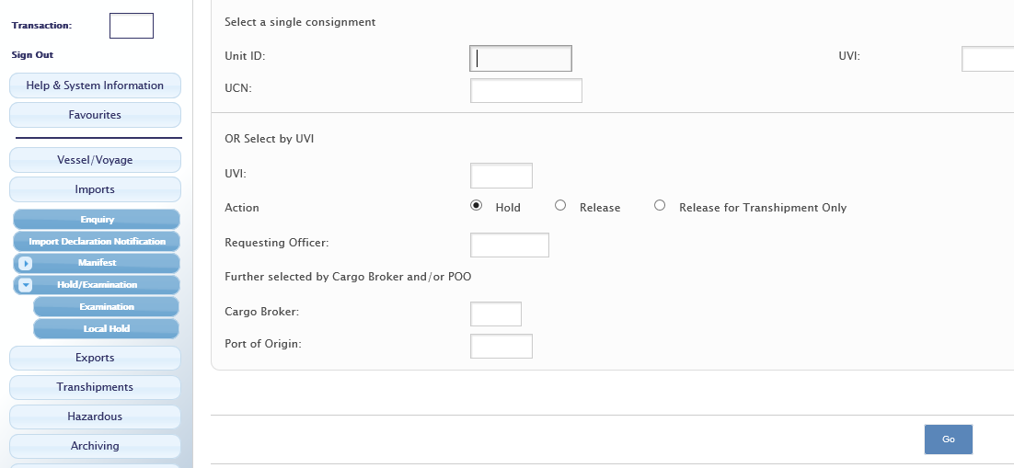

- Click Go.
- Repeat the requested details in the next window.
- Record on the holds spreadsheet as you place each hold, and make a note of the shipping agent for each consignment.
- Email each shipping agent with a list of their consignments you have held and ask them for the following:

“Please submit by email C88, bill of lading, commercial invoice and packing list to tsports@thurrock.gov.uk”

- Wait for import paperwork to be emailed in.

