Manifest Searching – CNS Compass

Ports

This section covers how to manifest search vessels arriving at London Gateway and Tilbury port on the CNS system.

Our current procedure is to browse the manifests on Monday for all vessels arriving at London Gateway and Tilbury over the next 7 days (Tuesday – Monday). You should avoid placing a hold on containers which are due to arrive on the present day as the agent will have arranged ongoing transport.

- Visit www.cnsonline.co.uk, enter your login details and click the CNS COMPASS icon
- Ensure Internet Explorer is in Compatibility View (Tools > Compatibility View > Add)
- On the menu bar, click Maritime Import and Voyage Search.

- On the left-hand menu, enter the following:
  - Site/Wharf – enter ‘LGP1’ for London Gateway or ‘JWQ1’ for Tilbury
  - Expected Arrival Date – enter the date range for Tuesday – Monday

- Click Search.
- You are now shown a table with all the vessels arriving within your specified date range. The main columns of interest are Vessel Name, Port of Origin and Expected Arrival Date.

- Click on the UVI (underlined in blue) in the first row to open details of this vessel. You can also see the Vessel Name, Port of Origin and Expected Arrival Date at the top of this screen.

- Click Review Manifest.

- Under the heading ‘Import Available Cargos’, you are shown a breakdown of the containers on this vessel and the corresponding Cargo Goods Description. At the bottom of this table you will see the text ‘Show’ – select ‘100’ from the drop-down menu so you can see as many containers as possible on one page.

- If you see any goods of interest under the ‘Cargo Goods Description’ make a note of the container number, country of origin and expected arrival date. Keep scrolling through all goods on this vessel.
- Close the window and press the screen back button to return to the list of vessels due to arrive, click on the next UVI and repeat the process.
- Once all ships have been checked you will need to select which consignments to hold from those you noted may have goods of interest.
- Go to Maritime Import and Add/Remove Hold

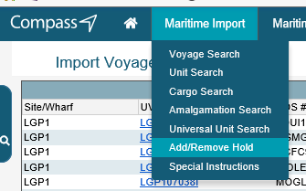

- Type the port reference code into the ‘Site/Wharf’ box in the top centre of the screen

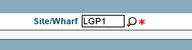

- Type the container numbers you wish to hold, select the hold type from the drop down menu (Trading Standards Hold K1) and type the following text into the reason box so the shipping agents know who to contact:

“Thurrock Trading Standards / tsports@thurrock.gov.uk / please submit by email C88, bill of lading, commercial invoice and packing list”

- Once all of the boxes are filled in click Apply Holds, multiple containers can be held at once.

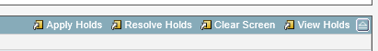

- Wait for the screen to refresh and check that a message comes up in the ‘Comments’ section that the hold has been applied for each container.
- Record on the holds spreadsheet what holds you have placed.
- Wait for the shipping agents to email the requested paperwork.

ETSF’s

This section covers how to manifest search consignments arriving at one of the ETSF’s in Thurrock on the CNS system.

Our current procedure is to browse the manifests on Monday for all consignments arriving over the next 7 days (Tuesday – Monday). You should avoid placing a hold on containers which are due to arrive on the present day as the agent will have arranged ongoing transport.

- Visit www.cnsonline.co.uk, enter your login details and click the CNS COMPASS icon
- Ensure Internet Explorer is in Compatibility View (Tools > Compatibility View > Add)
- On the menu bar, click ETSF and Unit Search.

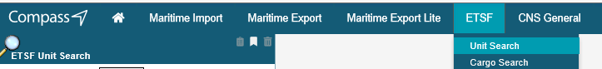

- On the left-hand menu, enter the following:
  - ETSF Site Code – e.g. ‘FPY1’ for Youngs
  - Expected Arrival Date – enter the date range for Tuesday – Monday

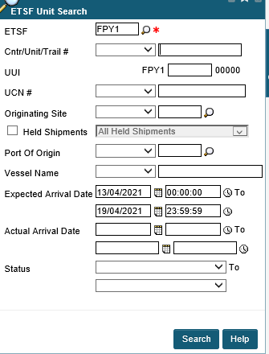

- Click Search.
- You are now shown a table with all the consignments arriving within your specified date range, the container this consignment has travelled in, the number of cartons and the vessel name.

- Click on the UCN (underlined in blue) in the first row to open details of this consignment. You can also see the Vessel Name, Port of Origin and Expected Arrival Date at the top of this screen.

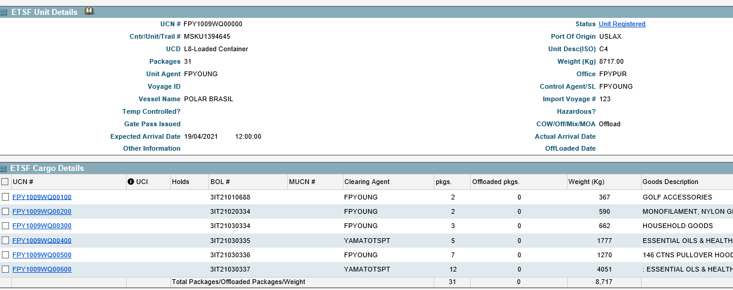

- Look at the ‘Goods Descriptions’ and if any are of interest select that UCN in the left column where the UCN’s are highlighted blue and underlined.
- A new window opens showing only that UCN, click Holds in the top right corner.

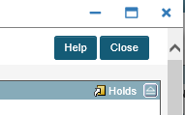

- Click Add Holds.

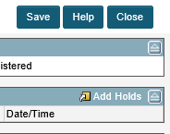

- Select the Hold Type from the drop down menu, and in the Reason box type the following:

“Thurrock Trading Standards / tsports@thurrock.gov.uk / please submit by email C88, bill of lading, commercial invoice and packing list”

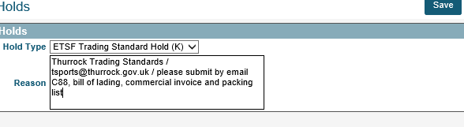

- Click Save.
- Check a padlock symbol appears next to the UCN to show a hold is in place, and if no other UCNs of interest in from that container press the back-up button.
- Select the next UCN in the list and repeat the process.
- Do this for each ETSF in the area.
- Record on the holds spreadsheet as you place each hold.
- Wait for the shipping agents to email the requested paperwork.

